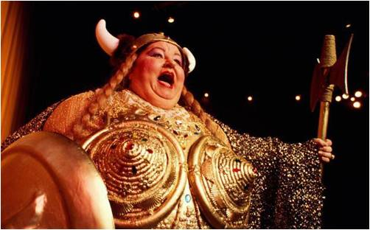
the FAT LADY might not be singing

But she is on the stage

“IF YOU’RE NOT SCARED YOUR’E NOT PAYING ATTENTION”
-Jamie Clifford

I. I believe we are in the midst of a once in a generation secular change that affects the entire spectrum of our lives— politics, economics, cultural and social issues. I think we are in a crisis, possibly an unraveling. History warns that environments that we are currently in always result in a structural change of the basic social and economic environment that you and I now take for granted. I believe the next 10- 20 years are going to be completely different than the last 10-20.
So I guess the question is—where are we headed? Well, as I see it I think we are in some deep shit. The bottom line is the U.S. Economic Model is UNSUSTAINABLE. I think the facts are there to support my thought process that within the next 10-15 years America will pass through a great gate in history. What type of an America will emerge from the crisis? I don’t know but I believe there will be some form of an economic reset or currency event within 10-15 years.
II. SOME THOUGHTS
- For the average Joe the recession which began in December 2007 is still in progress. Actually, I believe America could actually be on the precipice of a Second Great Depression. The first Great Depression ended only because of a World War, how will this depression end?
- There is a possibility of a type of a depression that is both deflationary and inflationary. We could see deflation for Financial paper assets while the cost of basic materials and goods that we need in which to live go much higher. This is a very bad-worst case scenario but one that has seemed to increase in probability each year. Most of that increase is due to an unwillingness to deal with the twin towers of destruction related to Debt and Money printing by Central Banks, Entitlements demanded by Citizens and then granted by the tooth fairy or idiot Politicians.
- This is my 4th year in a row saying that The European Union as it is today will never make it and if Germany were to leave the EU, it will collapse.
- The vast majority of jobs lost since December 2007 will never return.
- The U.S. stock market no longer serves as a gauge of the health of the U.S. economy. Rather it has morphed into a RoboBlack Box—0% Interest Rate—Central Bank Trading Casino. Gambling is fun and at times lucrative, but gamble at your own risk.
- The U.S. stock market will remain volatile for many years, with strong rallies and large corrections. The market is now a trading vehicle and should not be viewed as a way to create long term wealth. The risk adjusted—inflation adjusted—transaction adjusted returns since 2000 are absolutely horrible but I will trade both long and short when opportunity presents. The Fed controls all markets.
- The self-sufficient American Working Middle-Class (both white and blue collar) is being destroyed. The will of the people is ignored because the government has been bought by the financial and military industrial complex, with funding by the Federal Reserve and the banking cartel that pulls all the strings.
- Oil prices will remain high as long as the U.S. remains as war in the Middle East and a 30 year refusal by elected officials and the public to craft a sane energy policy.

- Buying Gold, silver or other physical assets is an insurance policy against corrupt Western governments, unelected and unchecked Central Banks, and crony capitalism. The free enterprise system as we have know it, no longer exists. Or as George Bush so eloquently put it, “I've abandoned free-market principles to save the free-market system.”
- Using General Accepted Accounting Principles The United States is beyond bankrupt but the world cannot accept a bankrupted U.S. (currency and bonds). We will pay debts through devalued dollars or some currency reset ala Bretton-Woods after World War II. The loser is the Average Joe and his family.
- Since 9/11 the American public has willingly allowed the government to strip liberties and freedoms away in the name of safety and security through passage of the Patriot Act, TSA, Homeland Security, National Defense Authorization Act, , and wars of aggression in Iraq, Afghanistan and Libya. The War on Terrorism is used at every opportunity to keep the sheep-like populace under control and in their holding pens. “Those who give up Liberty for Security, deserve neither.” –Ben Franklin
- Not all sociopaths wield knives and knotted cords. Some wear suits, and are exceptionally intelligent and articulate, obsessively driven, and are able to use and undermine the law and the rules for their advantage. These are the most dangerous people in the world and they seem to have risen to highest levels of American and European institutions.
- The so called Mainstream Media is neither mainstream nor journalists. For the most part they are Ivy League cultural elitists who believe in a European Socialist One World Government. They believe most Americans are lazy and stupid, a fact that I’m growing to actually believe.
- Forty years ago the smartest people in America graduated from Ivy League schools, now the most dangerous people in the world go to Ivy League schools.
- The mantra “Too big To Fail” has been sold to us by the Federal Reserve Board and a group of Government officials who have single handily done their best to destroy free market capitalism for reasons that I cannot quantify.
- The FEDERAL RESERVE and the GOVERNMENT has become by far and away the single most powerful player in all Investment Markets.

III. Demographics- I’ll paint broad brushstrokes and won’t get into the underlying “demographics” of entire groups of people that are increasing in population that will never contribute to wealth creation and will only suck it out from the system. Needless to say it is not an encouraging demographic outlook.
- Baby Boomers 76million 1943-1960. “The Worst Generation”
Never before has a generation knowingly and with reckless malice enslaved their children, grandchildren and great-grandchildren like the seventy-six million 50-75 years olds who have collectively rang up 150 trillion dollars in debt and entitlements. That number looks like this 150,000,000,000,000 and if you stacked a $100 bills on top of each other (not end to end but on top) that figure would stretch 10,185 miles into outer space. The collective long-term survival of the country has been cast aside in the name of the selfish desires of the generation in power.

- Generation X 1961-1981. “The Even Sum Group”

I call it the even sum generation because it is the first American generation that actually produces nothing and its incomes are generated from each other. For example: Attorney sues on behalf of client and wins a million dollars in a lawsuit. The lawyer and client make a million while someone loses a million. A Stockbroker makes $1000 in a commission but it is taken from his client. In reality nothing is produced or created—money is just transferred from one individual to another. So we had the Greatest Generation followed by the Worst Generation followed by the most apathetic.

- Mellennial (1982-2003) Can they save American in the next two decades? How many 18-25 year olds do you know? I’ll let you cast your bets on that one.

Lastly, I’ll leave this up to you to decide but which definition best fits the current state of the United States.

Constitutional Republic: “Constitutional republic” is a political philosophy of limited government, separated powers with checks and balances to ensure the federal government’s power stays limited within the Constitution, protected civil liberties, and elected representatives responsible to the people who retain the most political power. In the US we also embrace inalienable rights of the Declaration of Independence, and creative independence to cooperatively compete for our nation’s best ideas to move forward and be rewarded

Fascism: The definition of “fascism” has some academic variance, but is essentially collusion among corporatocracy, authoritarian government, and controlled media and education. This “leadership” is only possible with a nationalistic public accepting policies of war, empire, and limited civil and political rights.

“I contend that the greatest enemy of the United States is . . . the United States.”

DISCLAIMER: We live in a constantly changing world and I reserve the right to change any and all opinions and recommendations based on new information, developments, trends or being just plain wrong.

Charts to the Path to Tyranny
Non-Defense Government Spending at all levels (federal, state, local) as a percentage of GDP.

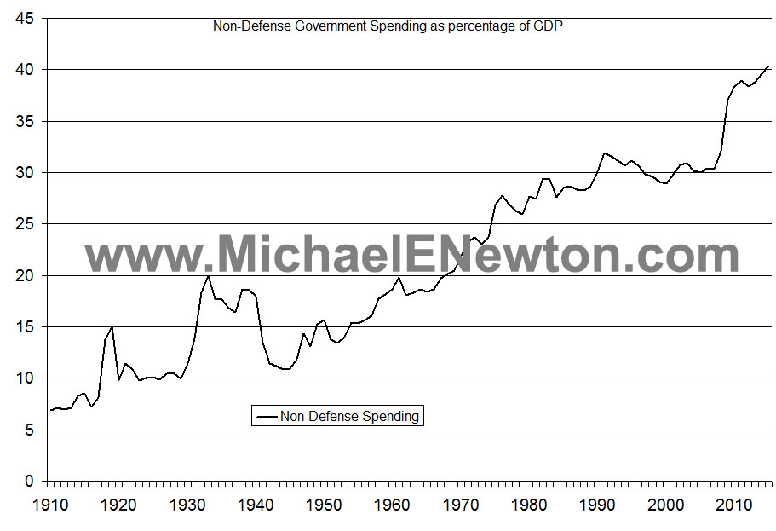
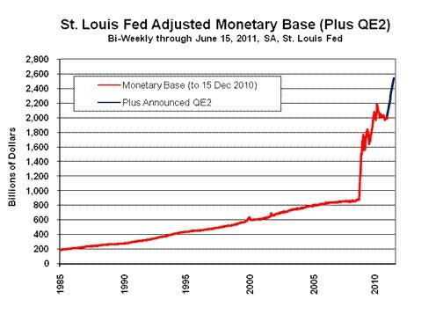

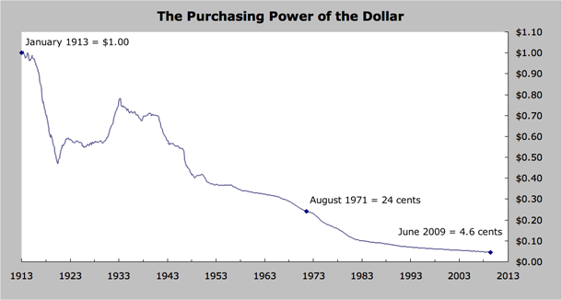

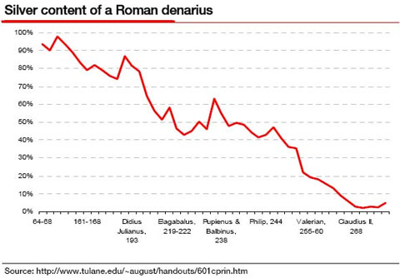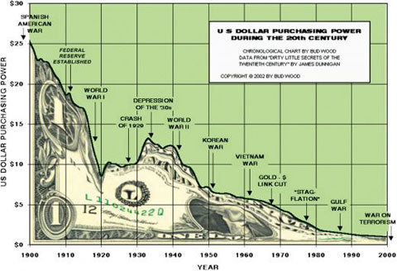

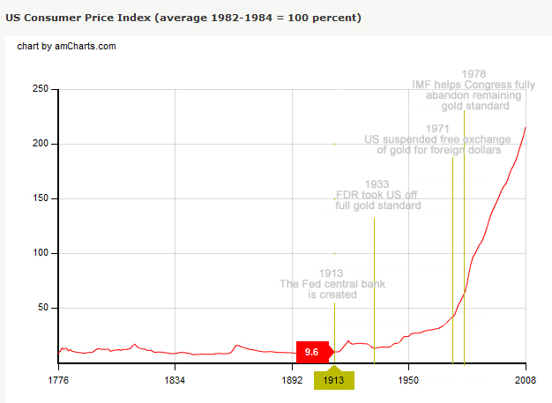
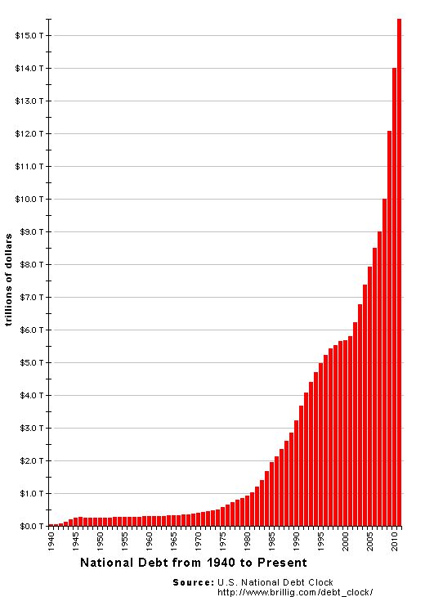

It has been a great last 11 years. Thanks George, Obama and Congress.

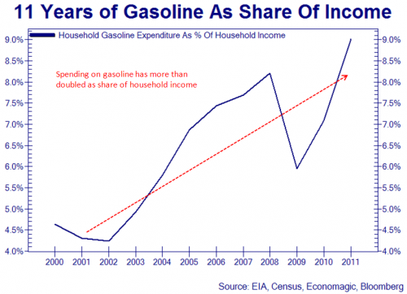

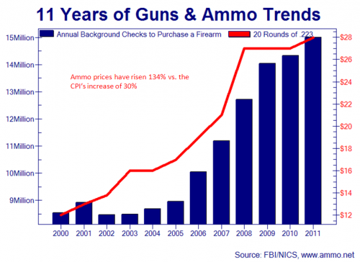

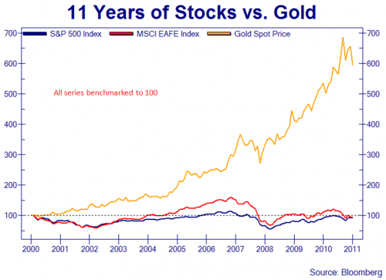
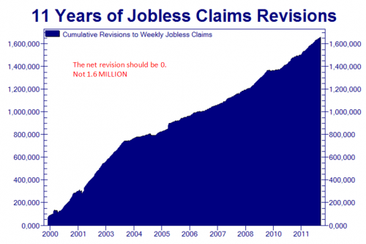
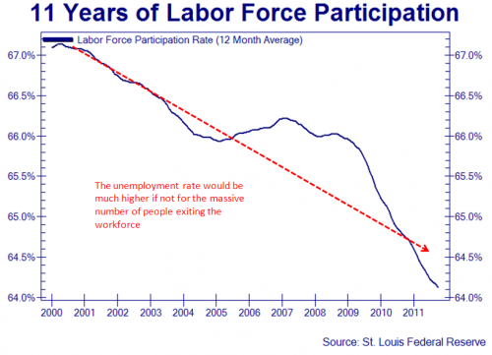

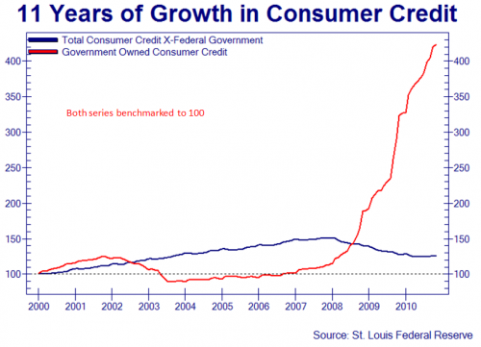

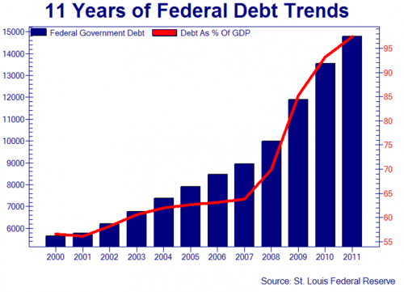

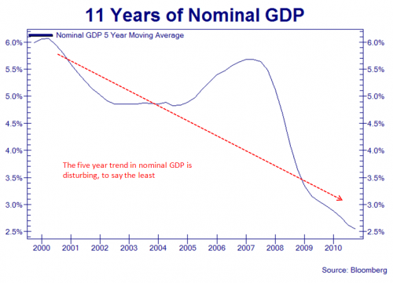

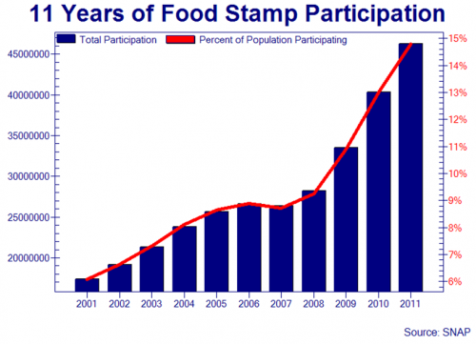
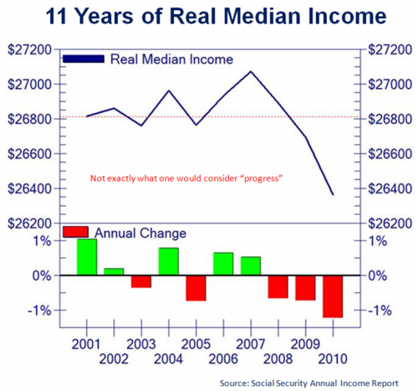

69 Abysmal Facts about the United States
SocioEconomic or Households
#1 A staggering 48 percent of all Americans are either considered to be “low income” or are living in poverty.
#2 45,000,000 million Americans are on food stamps. 1 out of 7 adults and 1 out of 4 children.
#3 25% of American Households have a Zero or Negative net worth
#4 41% of all working age Americans either have medical bill problems or are currently paying off medical debt.
#5 48.5% of all Americans live in a household that receives some form of government benefits.
#6 $337 Billion dollars was spent on prescription dugs last year
#7 1 out 45 homes are in foreclosure
#8 U.S. home values have fallen an astounding 6.3 trillion dollars since the peak of the real estate market in 2005.
#9 Average household debt in the United States has now reached a level of 154% of average household income.
#10 Americans now owe more than $900 billion on student loans, which is an all-time record high.
#11 In the United States today, there are over 15 million people who are "officially" considered to be unemployed for statistical purposes. But everyone knows that the "real" number is even much larger than that. When you throw in "discouraged workers" and "underemployed workers", the "real" unemployment rate in the state of California is actually about 22 percent.
#12 In the United States today, over 18,000 parking lot attendants, 100,000 janitors, 325,000 cashiers, 317,000 waiters and 80,000 bartenders have college degrees.
#13 Between 2007-2009 House hold Net Worth fell $17,000,000,000,000. That is 17 trillion dollars.
#14 Americans have $772 billion in outstanding credit card balances.
DEBT
#15 Amazingly, the U.S. government has now accumulated a total debt of 15 trillion dollars. When Barack Obama first took office the national debt was just 10.6 trillion dollars.

#16 Total debt including unfunded liabilities is over 125 Trillion Dollars.
#17 If the federal government began right at this moment to repay the U.S. national debt at a rate of one dollar per second, it would take over 440,000 years to pay off the national debt.
#18 The U.S. national debt has been increasing by an average of more than 4 billion dollars per day since the beginning of the Obama administration.
#19 During the Obama administration, the U.S. government has accumulated more debt than it did from the time that George Washington took office to the time that Bill Clinton took office.
#20 It is being estimated that total U.S. government debt will grow by 42 percent by the year 2015.
#21 For fiscal year 2011, the U.S. federal government had a budget deficit of nearly 1.3 trillion dollars. That was the third year in a row that our budget deficit has topped one trillion dollars.

MACRO
#22 42,000 factories have shut down since 2001
#23 The United States has lost an average of 50,000 manufacturing jobs per month since China joined the World Trade Organization in 2001.
#24 The US Dollar has lost a third of its value in just 10 years
#25 Ten years ago, the United States was ranked number one in average wealth per adult. In 2010, the United States has fallen to seventh.
#26 The television manufacturing industry began in the United States. So how many televisions are manufactured in the United States today? According to Princeton University economist Alan S. Blinder, the grand total is zero.
#27 Since the Federal Reserve was created in 1913, the U.S. dollar has lost over 98 percent of its purchasing power.
#28 U.S. government spending as a percentage of GDP is now up to approximately 36 percent.
#29 The average amount of time that a worker stays unemployed in the United States is now over 40 weeks.
#30 The median price of a home in Detroit is now just $6000.
#31 According to the U.S. Census Bureau, 18 percent of all homes in the state of Florida are sitting vacant. That figure is 63 percent larger than it was just ten years ago.
#32 One out of every seven Americans has at least 10 credit cards.

#33 Today, the “too big to fail” banks are larger than ever. The total assets of the six largest U.S. banks increased by 39 percent between September 30, 2006 and September 30, 2011.
#34 The six heirs of Wal-Mart founder Sam Walton have a net worth that is roughly equal to the bottom 30 percent of all Americans combined.
#35 40,000 new laws were enacted in 2011and a new 40,000 are ready to go for 2012.
#36 Global Markets lost $6.3 Trillion dollars in 2011.
#37 The Nasdaq has lost 50% of its value since 2000.
#38 The S&P 500 is exactly where it was 12 years ago.
#39 Auto sales peaked in 1985 (11 million) and have been declining at a fairly steady rate since 1999.
#40 There are an estimated 30 million surveillance cameras now deployed in the United States shooting 4 billion hours of footage a week.
#41 In 1980, government transfer payments accounted for just 11.7% of all income. Today, government transfer payments account for more than 18 percent of all income.
#42 Over 15 million lawsuits are filed every year. That works out to one new lawsuit every two seconds. Or one lawsuit for every 12 adults in America.
#43 The IRS tax code is 60,000 pages
#44 There are 1,500,000 million attorneys in the U.S.
#45 After accounting for inflation, median wages for men between 30 and 50 dropped 27 percent—to $33,000 a year— from 1969 to 2009,
#46 63% of Americans are considered overweight or obese
# 47 The average 65 year old has spent 9 years watching Television.
#48 The Average person watches 26 hours of TV a week.
# 49 80% of U.S. families did not buy or read a book last year.
#50 USA scores the lowest in national average IQ among the developed countries of the world, at a national average score of 98.
#51 GE filed a 57,000 page tax return and paid $0 taxes on a $14 Billion dollar profit.
#52 Albert Pujois signed a $254,000,000 contract to play a game 6 months out of the year.
#53 The National Debt was $12.50 per person in 1912 the year before the FED came into existence.

#54 10,000 baby boomers are retiring every single day. This will happen every single day for the next 19 years.
#55 There is over $700 Trillion dollars of unregulated derivative financial contracts.
#56 The collective net worth of all of the members of Congress increased by 25 percent between 2008 and 2010.
# 57 Insider trading is perfectly legal for members of the U.S. Congress - and they refuse to pass a law that would change that.
#58 the average family health insurance policy now costs over $15,000 a year.
#59 Average yearly tuition at U.S. private universities is now up to $27,293
#60 Between December 2000 and December 2010, 38 percent of the manufacturing jobs in Ohio were lost, 42 percent of the manufacturing jobs in North Carolina were lost and 48 percent of the manufacturing jobs in Michigan were lost.
#61 20 percent of all employed Americans are making $10.65 an hour or less
#62 New home sales in the United States are now down 80% from the peak in July 2005.
#63 18 percent of all homes in the state of Florida are sitting vacant
# 64 8 million Americans are currently at least one month behind on their mortgage payments
# 65 The 50 U.S. state governments (57 states if you are an Obama voter) are collectively 3.2 trillion dollars short of what they need to meet their pension obligations
#66 One third of the entire population of the state of Alabama is now on food stamps
#67 Our dollar is being systematically destroyed by the Federal Reserve. An item that cost $20.00 in 1970 will cost you $116.78 today. An item that cost $20.00 in 1913 will cost you $457.67 today
#68 The Federal Reserve made $16.1 trillion in secret loans to their Banking friends during the last financial crisis
#69 According to a new CNN/ORC International Poll, 27 percent of all Americans have never even heard of Federal Reserve Chairman Ben Bernanke

Stages of Civilization

The Savage State
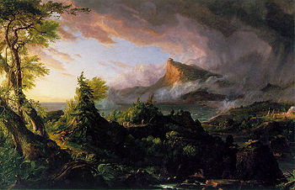
The Savage State.
The first painting, The Savage State, shows the valley from the shore opposite the crag, in the dim light of a dawning stormy day. A hunter clad in skins hastens through the wilderness, pursuing a deer; canoes paddle up the river; on the far shore can be seen a clearing with a cluster of wigwams around a fire, the nucleus of the city that is to be. The visual references are those of Native American life.
The Arcadian or Pastoral State
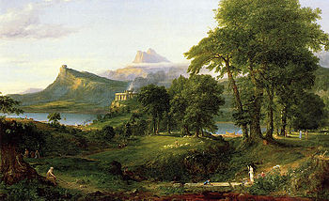
The Arcadian or Pastoral State.
In the second painting, The Arcadian or Pastoral State, the sky has cleared and we are in the fresh morning of a day in spring or early summer. The viewpoint has shifted further down the river, as the crag with the boulder is now on the left-hand side of the painting; a forked peak can be seen in the distance beyond it. Much of the wilderness has given way to settled lands, with plowed fields and lawns visible. Various activities go on in the background: plowing, boat-building, herding sheep, dancing; in the foreground, an old man sketches what may be a geometrical problem with a stick. On a bluff on the near side of the river, a megalithic temple has been built, and smoke (presumably from sacrifices) arises from it. The images reflect an idealized, pre-urban ancient Greece
The Consummation of Empire
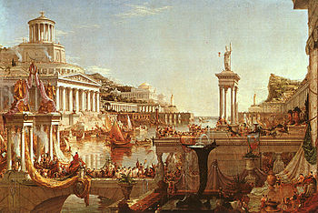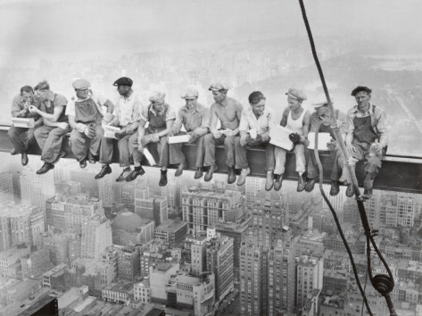
The Consummation of Empire. ^{[6]}
The third painting, The Consummation of Empire, shifts the viewpoint to the opposite shore, approximately the site of the clearing in the first painting. It is noontide of a glorious summer day. Both sides of the river valley are now covered in colonnaded marble structures, whose steps run down into the water. The megalithic temple seems to have been transformed into a huge domed structure dominating the river-bank. The mouth of the river is guarded by two pharoses, and ships with lateen sails go out to the sea beyond. A joyous crowd throngs the balconies and terraces as a scarlet-robed king or victorious general crosses a bridge connecting the two sides of the river in a triumphal procession. In the foreground an elaborate fountain gushes. The overall look suggests the height of ancient Rome
Destruction
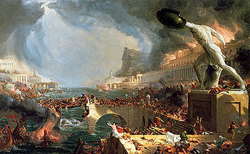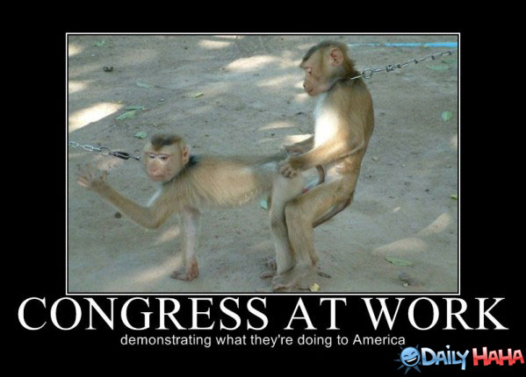
Destruction. Oil on canvas
The fourth painting, Destruction, has almost the same perspective as the third, though the artist has stepped back a bit to allow a wider scene of the action, and moved almost to the center of the river. The action is the sack and destruction of the city, in the course of a tempest seen in the distance. It seems that a fleet of enemy warriors has overthrown the city's defenses, sailed up the river, and is busily firing the city and killing and raping its inhabitants. The bridge across which the triumphal procession had crossed is broken; a makeshift crossing strains under the weight of soldiers and refugees. Columns are broken, fire breaks from the upper floors of a palace on the river bank. In the foreground a statue of some venerable hero stands headless, still striding forward into the uncertain future, reminiscent of the hunter in the first painting. The scene is perhaps suggested by the Vandal sack of Rome in 455.
Desolation
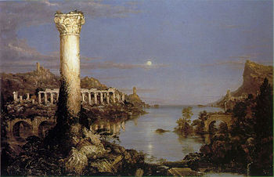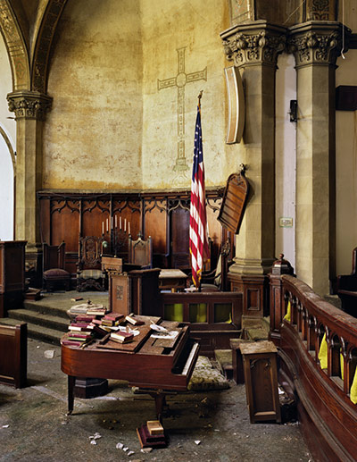
Desolation. Oil on canvas 2011 Detroit Woodward Avenue Presbyterian Church
The fifth painting, Desolation, shows the results, years later. We view the remains of the city in the livid light of a dying day. The landscape has begun to return to wilderness, and no human beings are to be seen; but the remnants of their architecture emerge from beneath a mantle of trees, ivy, and other overgrowth. The broken stumps of the pharoses loom in the background. The arches of the shattered bridge, and the columns of the temple are still visible; a single column looms in the foreground, now a nesting place for birds. The sunrise of the first painting is mirrored here by a moonrise, a pale light reflecting in the ruin-choked river while the standing pillar reflects the last rays of sunset.

The Course of Empire is a five-part series of paintings created by Thomas Cole in the years 1833-36

