THE CREATURE FROM JEKYLL ISLAND

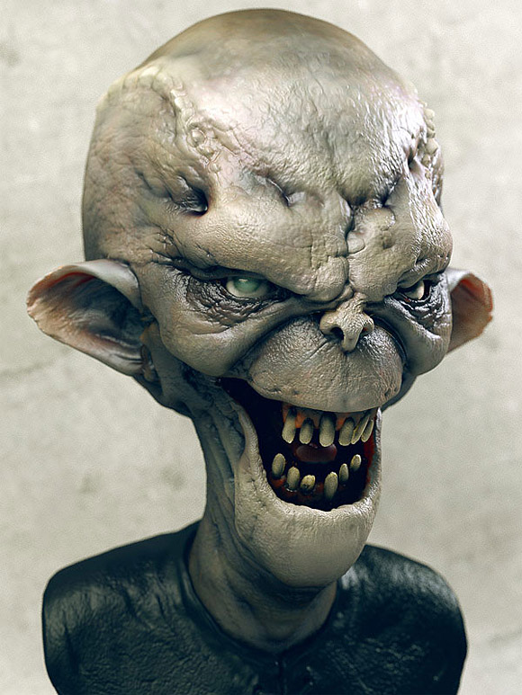

OR: HOW I LEARNED TO STOP WORRYING AND LOVE THE FED

Today I am going to tell you a horror story. It is about a creature that is far more terrifying and diabolical than any monster, any goblin, any evil that you could possibly imagine. Freddy Krueger, vampires, werewolves, Frankenstein—Ha, I scoff at these so-called evil abominations because they pale in comparison to the abject horror, the gut-wrenching havoc, and the terrifying destruction caused by the Creature from Jekyll Island.
And what makes this monster so heinous is that unlike Dracula or Jason from Friday the 13th the story I about to tell you is real. A century ago a monstrosity sprung out of the dark shadows from a remote island located off the coast of Brunswick, Georgia. It was called Jekyll Island and the reason this monster is so mind numbing frightening is that not only is it real but everyone in this country, whether you know it or not, is being stalked by this demon that threatens everything: Your life, liberty and pursuit of happiness.
So what does this creature look like? Well, through inside sources I have secured a picture straight from the secret vault of the X-Files but I must warn you, this beast is not a pretty sight and some of you may find yourselves involuntarily screaming out in horror. I say this not to scare you but only to warn. Ok, ready, here it is. Yes, the Creature from Jekyll Island is also known as: The Federal Reserve Corporation.
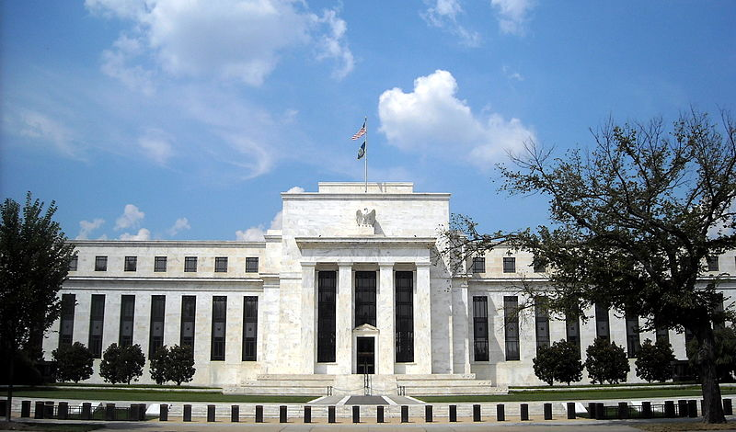
So now some of you might be thinking what sort of trickery is this? That is not the least bit scary. Well, give me a few moments of your precious time and let me tell you a little bit about the Federal Reserve Corporation and then you can decide for yourself whether or not this creature isn’t more terrifying than even your worst nightmares.
FIRST LET ME BRIEFLY TELL YOU A LITTLE BACKGROUND ON WHAT THE FED IS AND ISN’T. QUITE SIMPLY:
- Contrary to most people’s notion the FED is not part of the government or even a government agency. Most people think it is because it has the word Federal in it but it is no more federal than say, Federal Express.
- The Fed which is possibly the single most powerful entity in the world has never been fully and independently audited (July 2011 GAO under pressure performed a limited audit and discovered that $16 Trillion dollars was loaned to domestic and European Banks during 2008 Crisis). No Fed members are elected by a vote of American citizens and its decisions do not have to be ratified by the anyone in the executive, judicial or legislative branches of government.

- The Fed is privately owned and 100% of its shareholders are private banks. None of its stock is owned by the government. In Lewis v. United States, the United States Court of Appeals for the Ninth Circuit stated that: "The Reserve Banks are not federal instrumentalities, but are independent, privately owned and locally controlled corporations."
So then who are the shareholders? Banks—And it is interesting to see who the original shareholders of the FED were. They were the American and European Banking dynasties and here are the names of the original shareowners:

  - Rothschild Bank of London and Berlin
  - Warburg Bank of Hamburg and Amsterdam
  - Lehman Brothers of New York
  - Lazard Brothers of Paris
  - Kuhn Loeb Bank of New York
  - Israel Moses Seif Banks of Italy
  - Goldman, Sachs of New York
  - Chase Manhattan Bank of New York
Think I’m making this up. I got this information straight from the Encyclopedia Britannica.
So let’s travel back in time to try and understand how and why these monetary Wizards of Oz got away with their creation. By the way the real Wizard of Oz published in 1900 is thought to be a monetary allegory where the wizard is simply a manipulative politician who appears to the people in one form, but works behind the scenes to achieve his true means. Not much changes in a hundred plus years.
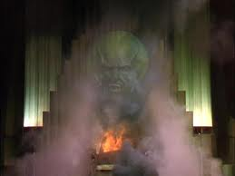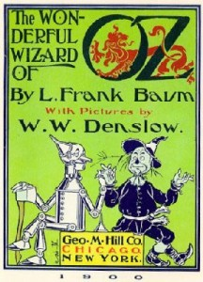
First a brief bit of history. Before the Fed the United States experimented very briefly with two Central Banks both of which ended in disasters. And it was quite clear that most of our founding fathers never intended for America to use a European Central Bank system because of the carnage that the system had wreaked upon its citizens.

In Ben Franklin’s autobiography he said “that the inability to get the power to issue money permanently and get it out of the hands of the International Bankers was the prime reason to fight the Revolutionary War.”
And Thomas Jefferson pretty much summed up his feelings about Central Banks when he said, “I believe that banking institutions are even more dangerous than standing armies.”
So fast forward to the turn of the 20th century and American is growing at a phenomenal rate and a small group of the world’s most wealthy individuals correctly believe that America is where they should place their bets and it’s pretty clear how they intended to conquer the US without a single shot being fired. Listen to Mayer Rothschild, patriarch of the Rothschild dynasty, describe how to really control a country, “Let me issue and control a nation’s money, and I care not who writes the laws.”
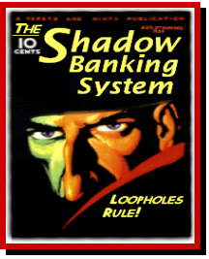
So the banking dynasties from Europe represented by the Warburgs and Rothschilds met in secret with the American dynasties of the Morgans and Rockefellers at Jekyll Island which was owned by JP Morgan. There they laid the framework for the establishment of the creation of a Central bank that they would control. Their strategy was to create a banking cartel which by definition is a group of independently owned businesses which come together for the purpose of eliminating or reducing competition between themselves in order to enhance their profit margin.
But they had to be crafty. They knew the American people wouldn’t stand for a central bank and they had to work behind the scenes to accomplish their mission. There chance came in 1912 when the cartel discovered that presidential candidate Woodrow Wilson was in desperate need of funds and they convinced Wilson to sign into law the Federal Reserve Act in exchange for funding his presidential campaign. Wilson grudgingly agreed and with the bankster’s money he won the 1912 presidential election. So on Christmas Eve 1913 with most opposing senators absent on Christmas break Congress sneaked through the Federal Reserve Act which Woodrow Wilson promptly signed into law.
As unbelievable as this first Act in my horror story is it gets better because Congress and the President knowingly and willfully violated the constitution of the United States. Article 1 section 8 states “that only congress shall have the power to coin (create) money and regulate the value thereof.” The Supreme Court has even ruled that Congress cannot delegate its power to another group so the bottom line is we have a private corporation unconstitutionally and illegally printing money and regulating its value. And that is the Federal Reserve Corporation.

By the way Wilson in reference to Federal Reserve Board in his book The New Freedom said,
“"A great industrial nation is controlled by its system of credit. Our system of credit is concentrated. The growth of the nation, therefore, and all our activities are in the hands of a few men . . . We have come to be one of the worst ruled, one of the most completely controlled and dominated Governments in the civilized world, no longer a Government by free opinion, no longer a Government by conviction and the vote of the majority, but a Government by the opinion and duress of a small group of dominant men."
Now like all good horror movies we’ve reach the scene where the babysitter is climbing up into the dark attic to check out the strange noises. And you’re sitting there with a hand over one of your eyes going “please whatever you do don’t go up there. How can you be so dumb?”
But the babysitter doesn’t heed the warnings and continues up into the attic and we keep watching so I guess I’ll continue on with our own horror story which is –
HOW AND WHY DOES THE FED CREATE MONEY OUT OF NOTHING
This is complicated, in fact, when Henry Ford who was an industrialist not a banker when asked about the Fed he said “it is well enough that people of the nation do not understand our banking and monetary system because if they did, I believe there would be a revolution by tomorrow morning.”
Now I could get into fractional banking and all that but for the sake of time let me break it down like this: The government needs money to fund things like wars, finance pork projects or even pay entitlements demanded by it citizens so they go to the Treasury and asks for let’s say a $1B dollars. The Treasury laughs and says “C’mon you guys spent all our revenues by March there is nothing left.”
Of course, the politicians don’t like that answer so they start complaining and whining about their reelection bids until finally the Treasury says “OK guys, don’t worry we’ll call our friends over at the Fed.”
The Fed official answers and says “sure we’d love to give you a billion dollars, no problem. So they write a check to the Treasury for a billion dollars. Now where did this money come from? The correct answer is—from nowhere. The FED literally created it out of nothing. So now the Treasury gets a billion dollars and in exchange it gives back to the Fed one billion dollars in US Government guaranteed bonds that pay interest to the Fed.
So the simplistic net net of this is and keep in mind this is all done digitally but— the Fed prints money out of thin air not backed by anything. Then they loan it to the Government to pay for things that there’s no actually money for. Then the FED a private corporation charges the Government interest and here is the best part—The Government taxes you to pay the interest to the Fed for money that they created from nothing.

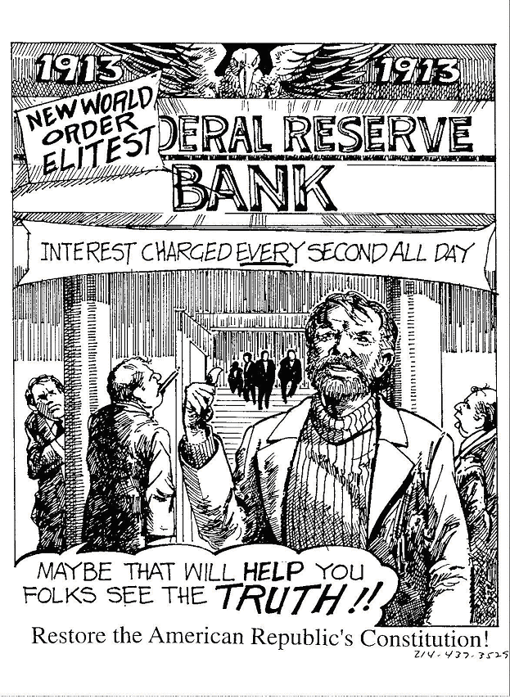
Now if you are starting to get a little confused, a little scared or maybe even a little angry, well you’d better hold on because the monster is now coming to get you, the defenseless taxpayer. See the United States never had a federal income tax. Yes, you heard me correctly no citizen of the US ever paid a federal income tax until after the Fed was created in, get this, 1913. Six months after the Fed was created Congress then passed the 16th amendment creating the federal income tax and IRS. Why? Because how else is the Fed going to collect the interest on the bonds. So the next time you write a check to the IRS when you get the check back look on the back and you will see a stamped endorsement that reads: “Payable to any Federal Reserve Branch.” Your taxes go directly to the FED not the U.S. Treasury.
At this point the babysitter now knows she made a colossal mistake by going up into the attic to investigate the scary noises but now it is too late, the door has slammed behind her and she is trapped in the attic with the unknown monster. She can feel the hot stank breath of the creature getting closer and closer. But her predicament is nothing compared to ours because the creature from Jekyll Island has even spawned a monster child . . . one that slowly gnaws a little piece of flesh out of each one of us every single day and that an insidious beast goes by the name of—inflation.
Perception is reality and we have just come to accept the fact that over time prices for things go up. Well, I’m here to tell you that we’ve been hoodwinked. Inflation is the most insidious tax of all and the Fed with compliance from the Government is directly responsible for the exponential rate of inflation that has plagued this country especially over the last 40 year.
Keep in mind that Inflation is not caused by rising prices. Rising prices are a symptom of inflation. Inflation is caused by too much money in relation to goods and services. Inflation is really the value of money going down simply because there is too much of it.
Our country has not always lived under a regime of perpetual inflation, rather on a historically basis it’s a rather recent development. A development that really took off when the very last checks and balances on the FED and our elected officials was destroyed. And that occurred in 1971 when Nixon took the dollar off the gold standard opening the doors to complete fiscal madness. One of the FED’s stated objectives is to maintain a stable currency. I’d say they’ve done one helluva great job since 1913 the dollar has lost 96% of its value with much of that coming in the last 40 years.

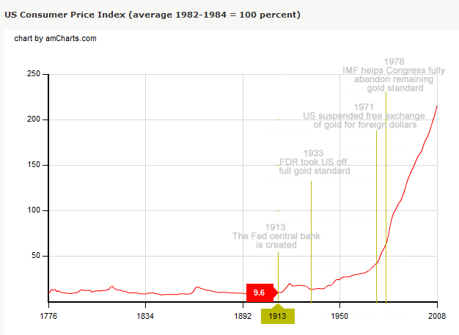

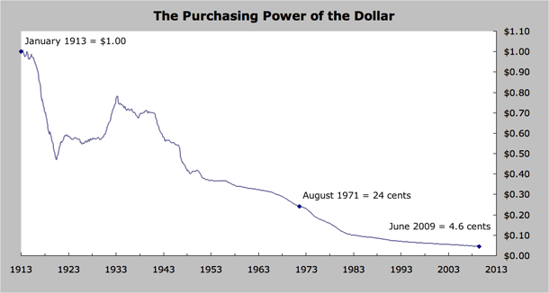

Unfortunately, even if this beast is slayed at this very moment it has left us with a curse that will plague this country for generations. And that curse is called debt or The Currency of Slaves. From the time of the first colony in 1665 all the way to 1913 almost 250 years the United States racked up a whooping $1 billion dollars of debt. But with the creation of the FED and the elimination of the gold standard it took less than 100 years for our national debt to go from $1 Billion to almost $15 Trillion and that is not really the full story.

Webster’s definition of debt is something owed or an obligation to pay. Everyone has seen the Debt Clock. Well the actual US debt is not $14.5 trillion it is really $150 trillion if we add in unfunded liabilities that the Government has promised to pay for things like social security, Medicaid etc.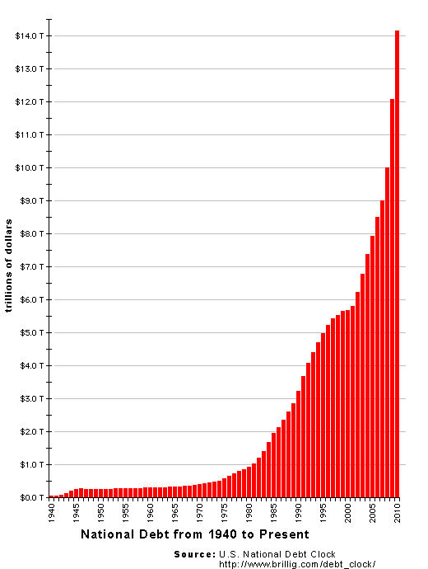

And to give you an idea how big a number a trillion is if we stacked $100 bills on top of each and I don’t mean side by side but if we stacked them on top of each other it 150 trillion dollars would stretch more than 100,000 miles into outer space.
But on a level everyone can better grasp: every Man, Woman and Child’s share of the national debt is $46,000 and each taxpayer is responsible for an additional $1,000,000 in unfunded liabilities.
Oh, and by the way, just in case you were wondering, before the FED in 1910 the total national debt per person in the United States was $12.40.
We all know what’s going to happen to the babysitter in the attic. So, let me ask you—how do you think our horror story is going to end?

FEDERAL RESERVE STATED OBJECTIVE taken directly from their website is to stabilize the economy with specific goals of currency stability, low inflation and preventing bank runs/failures. With those objectives and goals let’s give the Fed a grade.
- STABILIZE ECONOMY GRADE F-

We have been in a recession or depression for 28 years and 1 month or 28.57% of the time since FED came into existence in 1913. Additionally, there has been 9 stock market crashes greater than 40% and a Real Estate debacle as bad as the Great Depression that is still occurring.
Recessions Depressions
1913-1914 1yr 11months 1920-1921 1 yr 6mo
1918 7 mo 1929-1940 12 years
1923-1924 1yr 2 mo
1926-1927 1yr 1 mo
1945 8 mo
1953 10 mo
1958 8 mo
1960-1961 10 mo
1969-1970 11 mo
1973-1975 1yr 4 mo
1980 6 mo
1981-1982 1yr 4 mo
1990-1991 8 mo
2001 8 mo
2007-2009 1yr 6 mo

- DOLLAR STABILITY GRADE F-
The FED’S goal of dollar stability has resulted in the US dollar losing 97% of its value.

- LOW INFLATION GRADE F-
2500% increase in Consumer Price Index does not sound like “low” inflation to me.

- PREVENT BANK RUNS/FAILURES
20,000+ banks have failed since 1913.

So according to its own stated objectives the FED is a dismal failure of epic proportions. However, I am really going to throw a wrench into this story when I say the stated objectives of the FED were never its true goals.
Our horror story is now going to morph into Alice In Wonderland because the FED’S real goals are to make money for its shareholders which if you think about it should be the main objective for any corporation
But remember the FED is not only a corporation it is a cartel which is a group of business that come together to reduce competition and increase their own profits and not only that— they have the policing powers of congress because the FED is congresses mechanism for an unlimited blank check.

So I’ll give the FED an A+ it terms of achieving its real goals which are to act in its best interest. The FED and its bank owners are like the creature in the movie ALIEN. It is a perfect organism. A parasitic freak of nature that is virtually indestructible and the American Taxpayer is its victim.

Congressman McFadden's 1934 Speech on the Federal Reserve Corporation.
Quotations from several speeches made on the Floor of the House of Representatives by the Honorable Louis T. McFadden of Pennsylvania. Mr. McFadden, due to his having served as Chairman of the Banking and Currency Committee for more than 10 years, was the best posted man on these matters in America and was in a position to speak with authority of the vast ramifications of this gigantic private credit monopoly.

Whereas Mr. McFadden was elected to the high office on both the Democratic and Republican tickets, there can be no accusation of partisanship lodged against him. Because these speeches are set out in full in the Congressional Record, they carry weight that no amount of condemnation on the part of private individuals could hope to carry.

The Federal Reserve - A Corrupt Institution

"Mr. Chairman, we have in this Country one of the most corrupt institutions the world has ever known. I refer to the Federal Reserve Board and the Federal Reserve Banks, hereinafter called the Fed. The Fed has cheated the Government of these United States and the people of the United States out of enough money to pay the Nation's debt. The depredations and iniquities of the Fed has cost enough money to pay the National debt several times over.
"This evil institution has impoverished and ruined the people of these United States, has bankrupted itself, and has practically bankrupted our Government. It has done this through the defects of the law under which it operates, through the maladministration of that law by the Fed and through the corrupt practices of the moneyed vultures who control it.

"Some people think that the Federal Reserve Banks are United States Government institutions. They are private monopolies which prey upon the people of these United States for the benefit of themselves and their foreign customers; foreign and domestic speculators and swindlers; and rich and predatory money lender. In that dark crew of financial pirates there are those who would cut a man's throat to get a dollar out of his pocket; there are those who send money into states to buy votes to control our legislatures; there are those who maintain International propaganda for the purpose of deceiving us into granting of new concessions which will permit them to cover up their past misdeeds and set again in motion their gigantic train of crime.

"These twelve private credit monopolies were deceitfully and disloyally foisted upon this Country by the bankers who came here from Europe and repaid us our hospitality by undermining our American institutions.”

“The Federal Reserve Bank destroyed our old and characteristic way of doing business. It discriminated against our 1-name commercial paper, the finest in the world, and it set up the antiquated 2-name paper, which is the present curse of this Country and which wrecked every country which has ever given it scope; it fastened down upon the Country the very tyranny from which the framers of the Constitution sough to save us.”

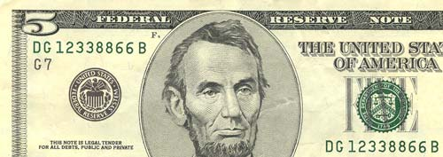

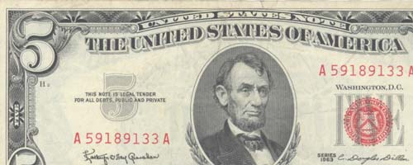

If we simply had the U.S. Treasury issue U.S. dollars(in the red)instead of the FED CORPORATION printing Federal Reserve Notes we could eliminate the structure of the FED and we could avoid unnecessary interest bearing debt to private middlemen who create dollars out of thin air.

The obvious question is why is Congress so complicit about the FED.
The simple answer is the FED provides them an unlimited blank check to do whatever they want.

Ever wonder why Congresses approval rating is so low but the same idiots get reelected every year? It’s easy to answer. Everyone hates politicians, except of course, our local or state guy or gals who promises us all kinds of goodies or entitlements that we don’t have to work for and they don’t have to really pay for.

So we hate everyone else’s politicians but we love ours and vote for them year after year after year. But make no mistake about it— WE are to blame because eventually someone will pay whether it is us or worse, our children or grandchildren.

BAILOUTS

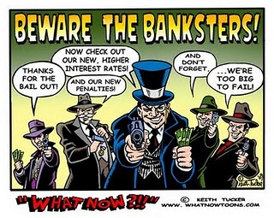
Prior to TARP the TopTen Banks held 55% of all bank deposits.
One of the “real” objectives of the FED is to protect its member banks and use the federal government to shift losses from the owners of those banks to the taxpayers. The guise for this is the notion of Too-Big-To-Fail always in the name of protecting American Citizens.
To date the amount for the bailouts has reached somewhere near 8.5 trillion dollars (some have the figure as high as $12.5 T) and foreign banks received $16 trillion of dollars directly from the FED during 2008 crisis. If Congress and the Fed were truly interested in helping Americans my suggestion would have been to let all the big banks fail and then we could have given $28,333 to every single man, woman, and child in this country (even the illegal immigrants). Where do you think our economy would be at if that happened?

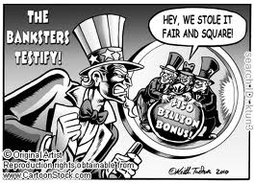
After TARP and the “we’ll never let Too-Big-To-Fail ever happen again Crap” the Big Ten now have 84% of all bank assets.

Federal Reserve Conspiracy: Just for fun for all those that believe in UFO’s, Big Foot and that Elvis is living in Bangladesh with Marilyn Monroe

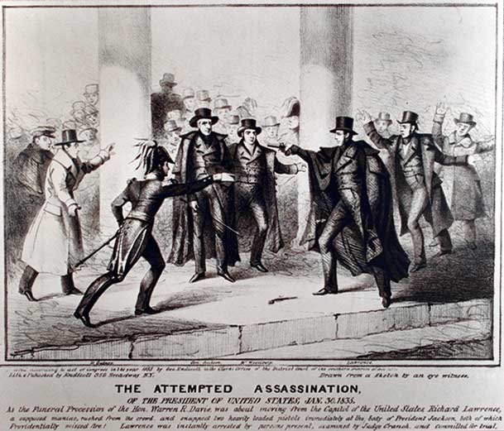
In 1832 Andrew Jackson runs on a campaign of “No More Bank.” He was referring to the 2nd US Central Bank that was controlled by the Rothschilds. His plan is to take control of America’s money system to benefit Americans rather than the Rothschilds.
He was quoted as saying to the Central Bankers, “You are a den of vipers and thieves. I intend to route you out by the eternal god I will route you out.”In 1835 an assassin tries to shoot Jackson but both pistols misfire. Jackson later claimed that the Rothschilds were responsible for the assassination attempt.

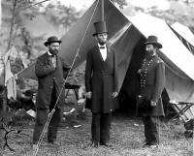
During the Civil War Lincoln needed cash but refused to pay International Bankers controlled by the Rothchilds interest rates of 24-36%. He passed the Legal Tender Act that employed the US Treasury to issue paper money called “greenbacks. The money was issued interest-free and debt-free and served as legal tender for all debts. After Lincoln is assassinated and Congress revoked the greenback law.

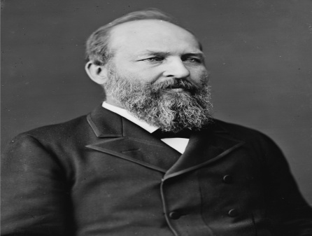
In 1881 James Garfield became president. He had been Chairman of the House Committee on Appropriations and was an expert on fiscal matters. President Garfield openly declared that whoever controls the supply of currency would control the business and activities of all the people. He was dedicated to restoring the right of the Federal Government to issue money like Lincoln. After only four months in office, President Garfield was shot at a railroad station on July 2, 1881.

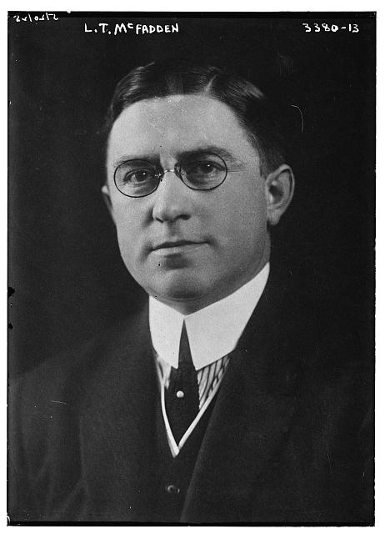
Louis T. McFadden, Chairman of the Banking and Currency Committee gave his famous speech in congress condemning the FED of treason (see section above for part of that speech) and suggesting that the FED is the most corrupt institution the world has ever known.
After his speech McFadden had two attempts on his life before dying under suspicious circumstances from food poisoning after a banquet.

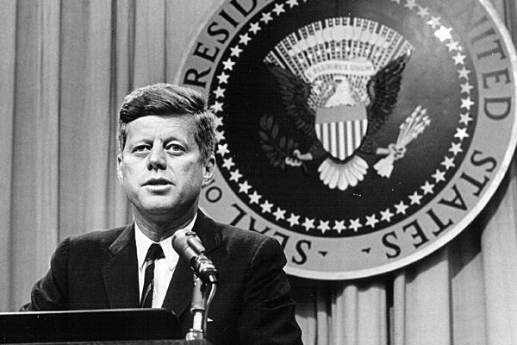
On June 4, 1963 John F. Kennedy understood the danger the Fed posed to the country and he issued Executive Order 11110 which authorized the U.S. Treasury to print “United States Note” which would be interest free and effectively end the Federal Reserve System. Just months after the executive order Kennedy was assassinated and Lyndon Johnson rescinded Kennedy’s order and the bank cartel continued.

A comment made by President John F Kennedy at Columbia University November 12, 1963, ten days before his assassination—

“The high office of the president has been used to foment a plot to destroy American’s freedom and before I leave office, I must inform the citizens of their plight.”

What You Can Do
- Get Educated. Read The Creature from Jekyll Island by G. Edward Griffin.
There are numerous websites and videos on the internet that expose the FED scam.
- Get out of personal debt.
- The Fed can be purchased by the U.S. Congress for $450 million dollars.
- Tell your congressman support legislation to audit the FED. Better yet tell them to introduce legislation to abolish the FED.
- DEMAND your congressman/senator to pass balance budget amendment to constitution.
- Do your business with local/small banks or credit unions.
- You don’t have to vote for him but at least voice support for Ron Paul’s 30+ year crusade to end the FED.
- Secrecy is the Fed’s main strength so please tell your friends and family about this.

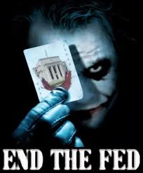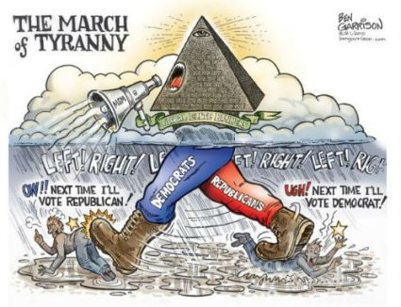
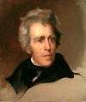

Basically, all insightful content and information was taken from other sources including:
The Creature from Jekyll Island, G. Edward Griffin
Encyclopedia Britanica
Federal Reserve Website
U.S. Constitution
Bigeye
Wtv-Zone
Seeking alpha
The Conspiracy that is the Fed, Chip Wood
Global Research
Michael Sickler
WhistleBlowers
HealthFreedom
Apfn.org
Wall Street Journal
Wikipedia
Ellen Brown, Global Reserve
Any and all errors are mine.

